
School of Computing and Digital Technologies

Software Architecture and Design
(55-608809)

Software Architecture and Design Document

Project: Complaint Management System (CMS)

Name | ID
Kaleb Durham | C3031562

Date: 07/10/2025

Table of Contents
Introduction 3
Overview 3
Solution Architecture 4
Non-Functional Requirements 4
C4 Context Diagram (level 1) 4
C4 Container Diagram (level 2) 4
Technology Stack 4
Solution Design 4
User Interface Design 4
C4 Component Diagram (level 3) 4
C4 Code Diagrams (level 4) 4
API endpoints 4
Data Design 4
Security Considerations 4
Appendix 1: Transparency Declaration Statements 5
Appendix 2: Refined User Stories 5
Appendix 3: Use Cases 5
Appendix 4: Architecture Decision Records 5
Appendix 5: Incorporation of Formative Feedback 6
Appendix 6: 7
References 8

Introduction
This is A descriptive report (Software Design Description). It should include artefacts produced at part of architecture and design. It should also include the decisions taken during architecting and designing. Formative feedback should also be incorporated.
(~3000 words excluding title page, toc, appendices, and references).
Guidelines for using this template:
- Please read this template along with the assessment specification
- This is intended as indicative guide to use for descriptive report, you may make changes as you see fit
- Rename the file to include your name, e.g. “<Your Name>_ SAAD Portfolio.docx”
- Delete all sections descriptions before you start. As they are meant for guidance only and not to be included in the final submission.
- Make sure all diagrams are clear, and captions used for all diagrams and tables.
- Add brief diagram description if needed to further explain your design.
- Use APA referencing to support your work
- All models/diagrams included in this report can be submitted in a zip file, This will include the diagram in a format using a suitable modelling environment available on a standard university desktop (e.g., StarUML, Visual Paradigm or draw.io) or as good quality image or pdf files (i.e., ones that you can easily read all details) - Suggestion, use vectorial images when exporting from the chosen tool.

Overview
Add a brief overview of your understanding of the problem description and an overview of the content of the rest of the document
The CMS is a multi-tenant helpdesk application that enables consumers of client organisations (for example, banks and telecom operators) to log complaints via web, mobile, and telephone channels. The CMS will manage end-to-end complaint lifecycle from complaint login, ticket allocation, ticket update history through to closure once the consumer confirms the issue is resolved. Due to the nature of the complaints, some will contain sensitive information about the companies so there is a significant focus on multi-tenant data isolation so that each client’s users can only access their own data as this could be a critical vulnerability to other systems they depend on. The goal of the CMS is to streamline the complain resolution process and support a growing userbase through onboarding new tenants to the system. From this I am tasked with extrapolating further requirements of the system such that I can design a software that will satisfy ABC Limited’s expectations.
The system will include 5 distinct user roles:
- Consumers – Tenant customers who create complaints and view status/history and resolution notes.​
- Support Persons – Tenant staff who work on assigned complaints and record comments, resolution notes and status changes.​
- Help Desk Agents – Tenant staff who attempt first-contact resolution, and assign complaints to support staff.
- Help Desk Managers – Tenant staff who monitor resolution performance and manage users within their tenant boundary.
- System Administrators – System operators who onboard/configure tenants and manage accounts/roles, but do not access tenant complaint content as to maintain confidentiality.
From the requirements I decided to use a monolithic architectural style with a MVC (Model-Views-Controller) design pattern as this is provided by the PHP Laravel framework which is the technology I will be using to develop the proof of concept. I chose this due to the speed of delivery it provides and because this is a widely-used framework within the industry that I haven’t learnt before, it’s also possible to then refactor the software to support services/modularisation in the future.
For the scope of the Proof-of-Concept I will be following these requirements to highlight the basic complaint lifecycle alongside showcasing how the data isolation should function:
- RF01 - Online Complaint Registration
- RF14 - Multi-tenant data isolation
- RF04- Assign Ticket to Support Person
- RF05 - Support Person Ticket Update
- RF06 – Consumer status tracking
- RF18 - Role-based action restriction
- NFR20 – Form Validation Feedback
- NFR08 - The system shall allow system admins to add and remove user accounts.

Solution Architecture

Functional Requirements

ID - Title | Description | Acceptance Criteria | Priority
RF01 – Online complaint registration | Allow consumers to register complaints online, capturing required details (tenant, category, description, contact) and generating a unique complaint ID. | Given an authenticated consumer, when a complaint form is submitted with mandatory fields, then a unique complaint ID is created, the complaint appears in the consumer’s history. | High
RF02 – Telephone complaint logging | Allow help desk agents to log complaints on behalf of consumers calling the helpdesk, including caller details, problem description, and channel metadata. | Given a help desk agent with access to the agent console, when call data and complaint details are entered and saved, then a complaint record is created and linked to the consumer, with the agent recorded as creator.
RF03 – Complaint lifecycle management | Manage a complaint’s status such as Open, In Progress, Resolved, and Closed from creation to closure, including re-opening if required. | When status is updated by authorised roles, the state transition follows configured rules, is time-stamped, and history is visible in the complaint details. | High
RF04 – Assignment to support person | Enable help desk agents to assign complaints to specific support persons or queues based on skills or categories. | When an agent selects an eligible support user or queue and confirms assignment, the complaint assignee is updated, the support person sees it in their worklist, and an assignment notification is sent. | High
RF05 – Support resolution update | Allow support persons to record resolution notes, and update status when work is completed. | Given an assigned support person, when resolution notes and outcome are saved, then the complaint status is updated appropriately, and the consumer-facing view shows the latest resolution information. | High
RF06 – Consumer status tracking | Allow consumers to view the current status and history of their complaints via web or mobile self-service. | Given an authenticated consumer, when they open “My Complaints,” then all their complaints and statuses are listed, and the details view shows timeline and resolution notes. | High
RF07 – Status updates via help desk ticket search | Allow help desk agents to provide the latest status to consumers during calls using an agent dashboard with search and filters. | When an agent searches by complaint ID or consumer identifier, the current status and latest updates are displayed for sharing with the caller. | Medium
RF08 – Consumer satisfaction and closure | Allow consumers to confirm whether their issue is resolved and record satisfaction (for example, rating or yes or no) online, enabling complaint closure. | When a complaint is in a resolvable state and the consumer submits satisfaction feedback, the complaint is marked Closed or Reopened according to the response and a confirmation is shown. | High
RF09 – Feedback via help desk | Allow help desk agents to record a consumer’s satisfaction or confirmation of resolution provided over the phone. | When an agent captures resolution confirmation during a call and submits it, the complaint is transitioned to Closed with the agent and timestamp recorded. | Medium
RF10 – Performance monitoring dashboard | Provide help desk managers with dashboards to monitor resolution time per complaint, agent performance, and support person performance within their organisation. | Given a manager role, when they access dashboards, key indicators such as average resolution time, volume per agent, and service level agreement breaches are displayed and can be filtered by date and category for their tenant only. | High
RF11 – Tenant onboarding | Allow system administrators to onboard new organisations, configuring tenant profile, branding, and operating parameters such as channels and working hours. | When an administrator completes the onboarding wizard with required details, a new tenant is created, tenant-specific configuration is stored, and default roles are provisioned. | High
RF12 – User and role management | Enable system administrators to manage users and privileges per tenant, including creation, activation, deactivation, and role assignment (consumer, agent, support, manager). | When an administrator updates a user’s profile or roles, the changes are persisted and effective immediately in access control checks across the CMS. | High
RF13 – Multi-channel notifications | Send notifications such as email, SMS, or in-app messages on key events such as complaint creation, assignment, status changes, and closure, based on tenant configuration. | When a configured event occurs, notifications are dispatched to the consumer and or staff as per tenant settings, and delivery status is logged. | Medium
RF14 – Multi-tenant data isolation | Ensure that complaint data, users, reports, and configurations are logically separated across tenant organisations in all user interfaces and application programming interfaces. | When a user belonging to one tenant accesses the system, only data for that tenant is visible and accessible, and cross-tenant access is blocked by authorisation controls. | High
RF15 – Channel configuration and hours | Support per-tenant configuration of telephone service hours and available channels such as enabling or disabling phone or web intake. | When an administrator updates operating hours or channel availability for a tenant, the system enforces these settings in user-facing components, such as displaying offline messages for closed hours.
RF16 – Reporting and analytics | Provide reporting capabilities for trends in complaints by category, channel, and time, to support data-driven decisions. | When a manager runs a report for a date range, complaint counts and metrics are generated accurately for their tenant and can be exported in a standard format. | Medium
RF17 – Chatbot-readiness interfaces | Expose structured complaint and knowledge data through well-defined interfaces to enable future chatbot integration. | When a chatbot or external client calls the defined application programming interfaces with valid credentials, structured complaint and status data is returned without dependency on the user interface. | Low
RF18 - Role-based action restriction | Provide role-based access control so that certain user roles are limited to a defined subset of actions within the system (for example, viewing but not editing complaints, or updating status but not closing complaints). | Given a user with a restricted role, when they use the system, only the actions granted to that role are available in the interface and through any APIs, and attempts to perform non-permitted actions are blocked without affecting other tenants.

Non-Functional Requirements

ID | Theme | Description | Priority (MoSCoW)
NFR01 | Availability | The system shall be available 99% of the time during working hours. | High
NFR02 | Performance | The system shall respond to user requests within 3 seconds under normal load. | Medium
NFR03 | Usability | The system must be easy to use, with clear instructions and navigation. | High
NFR04 | Security | The system must encrypt user credentials and sensitive data to protect user information. | Medium
NFR05 | Extensibility | The system must be designed to support future extension, such as adding chatbot support. | Medium
NFR06 | Data Retention | The system shall retain complaint logs for at least 6 months. | High
NFR07 | Portability | The system must work on standard web browsers and mobile devices. | Medium
NFR08 | Manageability | The system shall allow administrators to add and remove user accounts. | Medium
NFR9 | Interface | The system must have a simple and intuitive interface suitable for non-technical users. | High
NFR10 | Scalability | The system shall support a projected 10-year increase in users, starting from 20 million customers of a bank client (e.g., Barclays). | High
NFR11 | Security | The system shall isolate data between tenant organizations so that no data from NatWest is visible to Barclays and vice versa. | High
NFR12 | Availability | The system should provide 24/7 online service availability to allow logging of complaints at any time. | High
NFR13 | Accessibility | The system's web and mobile interfaces shall follow WCAG 2.1 standards to ensure usability by users with disabilities. | High
NFR14 | Usability | The system should provide a consistent, seamless experience. | High
NFR15 | Privacy | The system shall ensure GDPR compliance by protecting users' personal data and providing options to manage data. | High
NFR16 | Extensibility | The system could be designed to allow future integration of a chatbot for automated problem resolution. | Low
NFR17 | Operability | The system should support standardized hours of telephone service operation, varying by client company. | Medium
NFR18 | Maintainability | The system shall facilitate data-driven decision making by generating performance and complaint resolution reports for managers. | Medium
NFR19 | Backup & Recovery | The system shall perform regular backups and ensure data integrity to prevent data loss during failure events. | High
NFR20 | Usability | The system shall provide clear, actionable form validation feedback when users submit invalid or incomplete data, by highlighting the fields in error and displaying human-readable guidance on how to correct each issue | High
NFR21 | Usability | The system shall present role-appropriate screens and permitted actions so that users only see functions relevant to their role. | High
NFR22 | Usability | The system shall support efficient ticket triage by providing list views with key ticket attributes (e.g., ID, title, owner, priority, status, last updated) . | High

C4 Context Diagram (level 1)
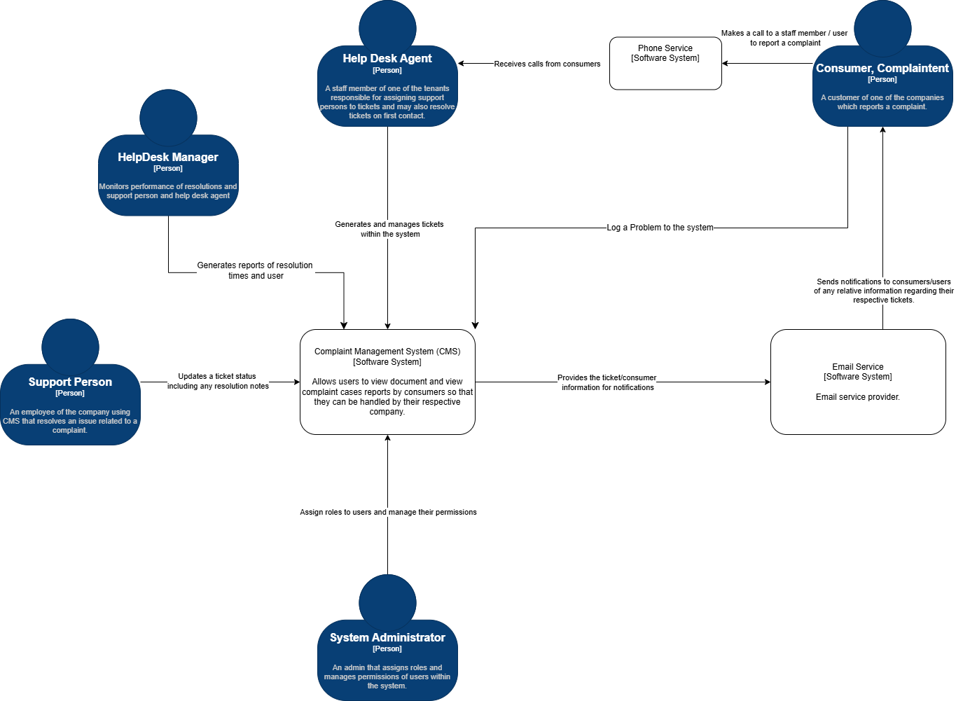
Each user directly interacts with the CMS however consumers may also call a helpdesk agent to create a ticket for them within the system. There is one external system which is the email service which would notify consumers of any updates made to tickets that they own.

C4 Container Diagram (level 2)
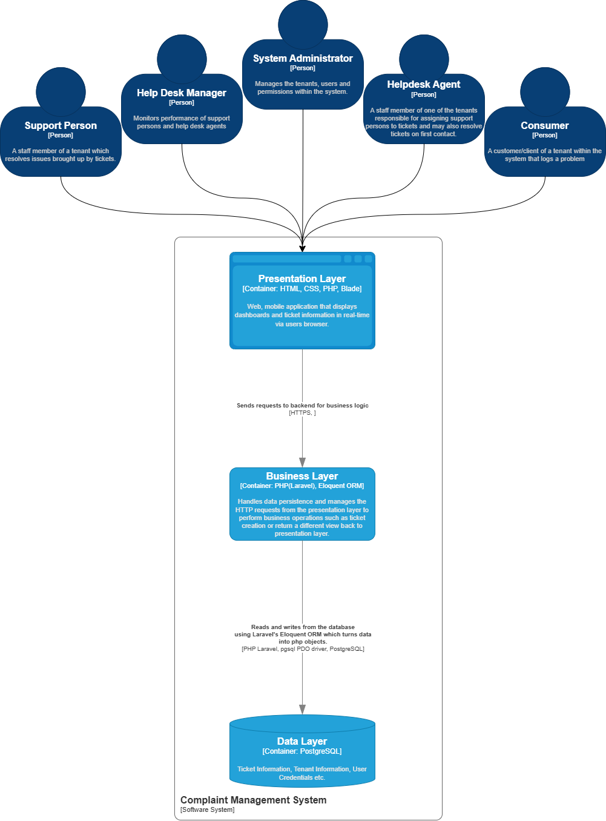
In this diagram, I have outlined the 3 different containers which represent the 3 layers that will be inside of the system monolith. The first of which is the presentation container/layer which will house frontend functionality to act as the endpoint in which the users interact with the system itself. This then sends requests to the business layer which is responsible for delegating requests and then using them on core logic processes to manipulate database and/ or return responses/views.

Technology Stack
Development Environment – Laravel Herd
Frontend – HTML, CSS, JS, Blade
Backend – PHP Laravel, Eloquent ORM
Database – PostgreSQL(pgAdmin4)

I have also included the Technology stack in my Architectural Decision Records within the github link attached under Appendix 4 of this document.

Solution Design

User Interface Design
The pages I have chosen to design are login page, ticket index (table view) , ticket update view, and ticket creation view. I have chosen these as they are a part of the core functions within the complaint management lifecycle therefore it is important that these follow usability requirements due to the estimated higher user traffic.
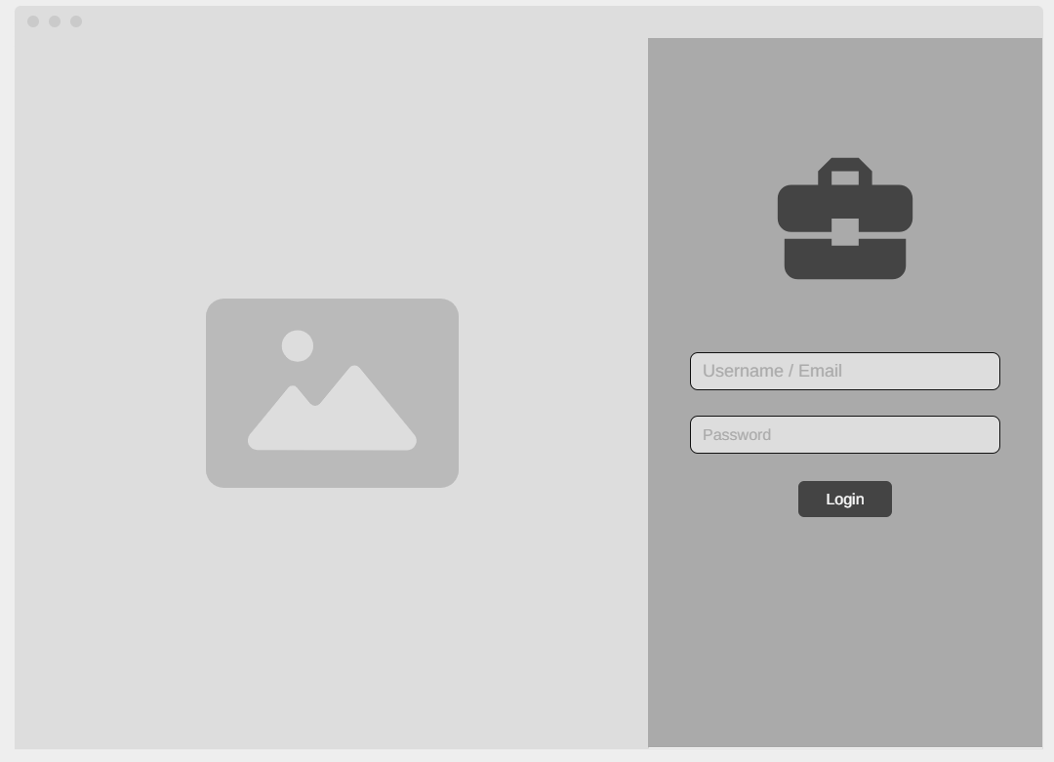
Login Page
Login functionality in which a user enters their email or username then password to access the CMS. This provides authentication to satisfy role-based authentication requirements. The form is kept minimal at only 2 fields to increase ease-of-use. I have also labelled each field so that non-technical users understand what is required of each field.

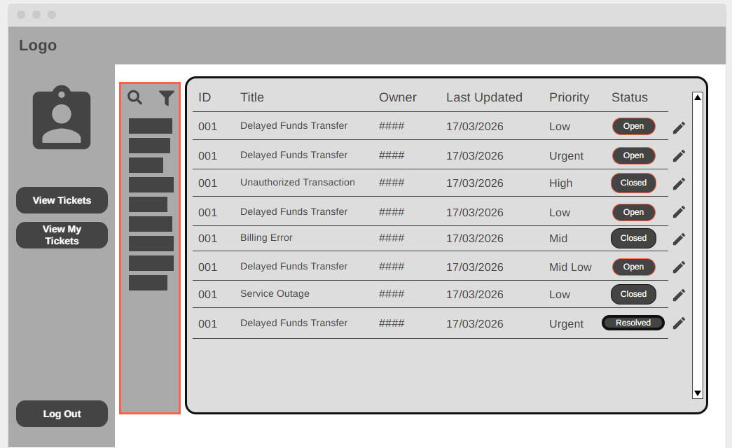
Ticket Index ( Table )
This is the main ticket index view in which authorized users can view ticket records along with an edit link to direct them to the update page for that specific ticket. To comply with NFR03(clear navigation) I have used a left-side navigation with clear labelled actions for non-technical users as well as NFR22 ( efficiency of common tasks) as the ticket list allows for rapid scanning plus a filter option to increase ease-of-use.

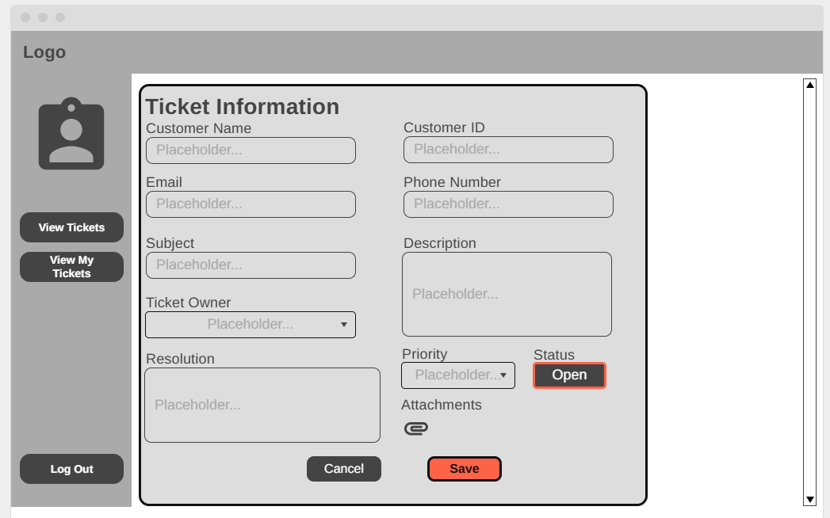
Ticket Edit Page
Within this form I have include some example fields which the user may be able to update within the ticket form. I have highlighted the status and save button to draw attention to support straightforward task completion, each field is labelled and given differing field types to communicate what action the user should perform for each e.g. dropdown, paragraph, single line.

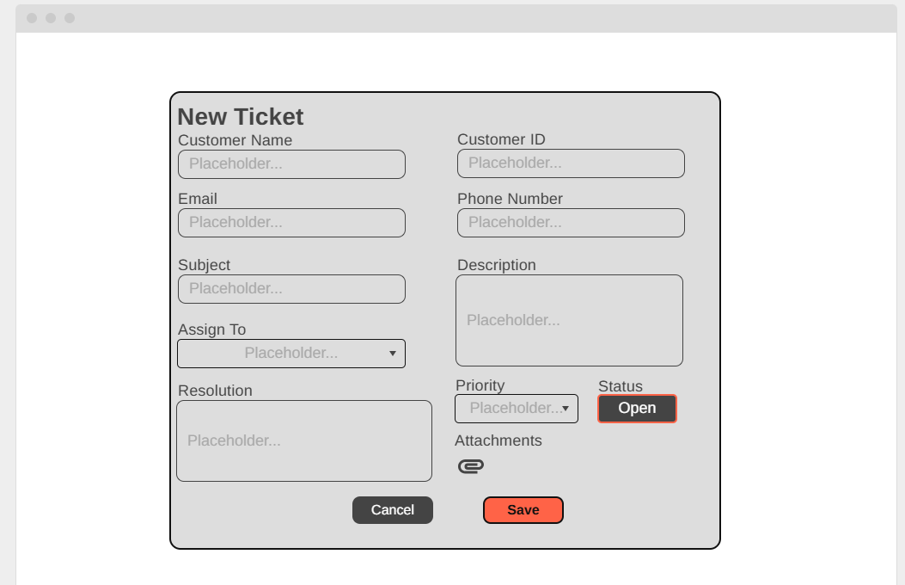
Ticket Creation (Staff)
Using the same format as the ticket edit page, I have provided a form for creating a new ticket with some example fields to showcase what type of details may be entered into the ticket information. As it uses the same format it complies with NFR14 (consistent user experience). Furthermore, this satisfies NFR21 (Role-Appropriate screens) as this is exclusive to staff members as consumers shouldn’t be able to assign a role.

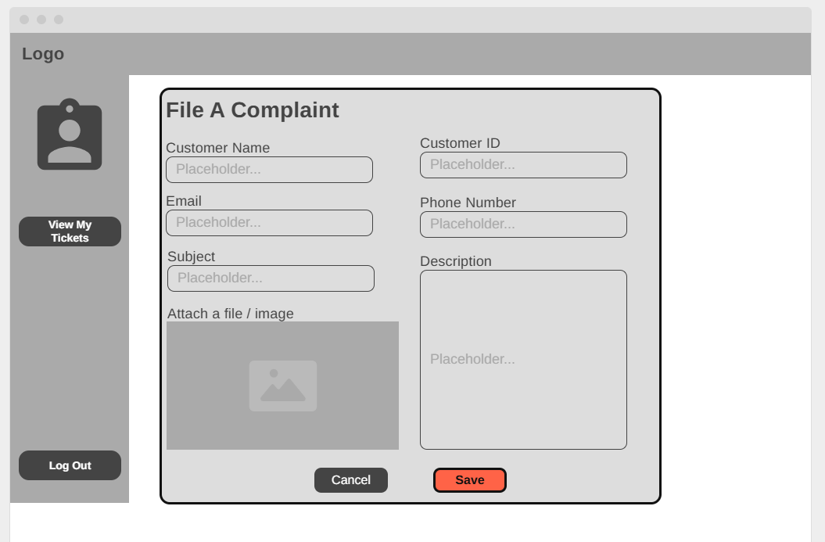
Consumer Ticket Creation
This allows customer to file a new complaint as a ticket but without assigning a user to the ticket as they will not have access to that functionality satisfying NFR21. This is further reinforced as the nav bar has also been reduced to only allow them to view their own tickets.

C4 Component Diagram (level 3)
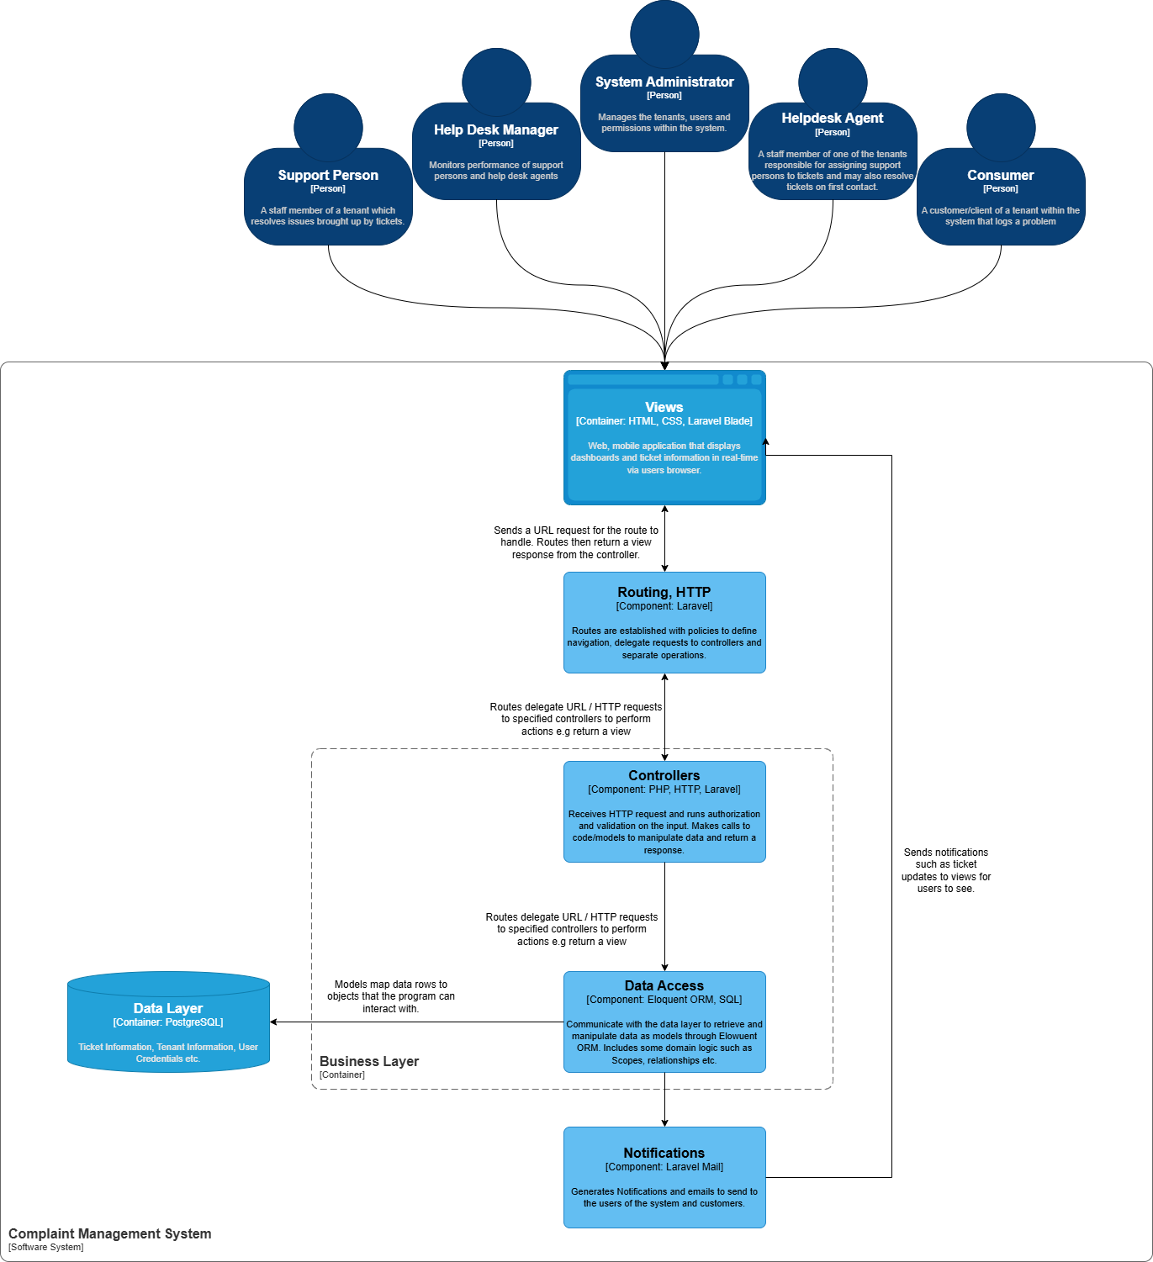
This diagram represents the key components within the business layer container. I chose this as it represents the majority of the MVC design pattern (Model and Controllers) which contains the application rules that enforce tenant boundaries and permissions(Data Isolation, RBA) as well as logic to all read/write interactions with the database. It showcases how the route handler maps user requests to relevant controller endpoints. The controller then performs validation, authorisation and tenant scoping checks before persisting/ retrieving data through the model layer, it may also return a view back to the view without accessing model layer depending on the request.

C4 Code Diagrams (level 4)
- Structural diagram

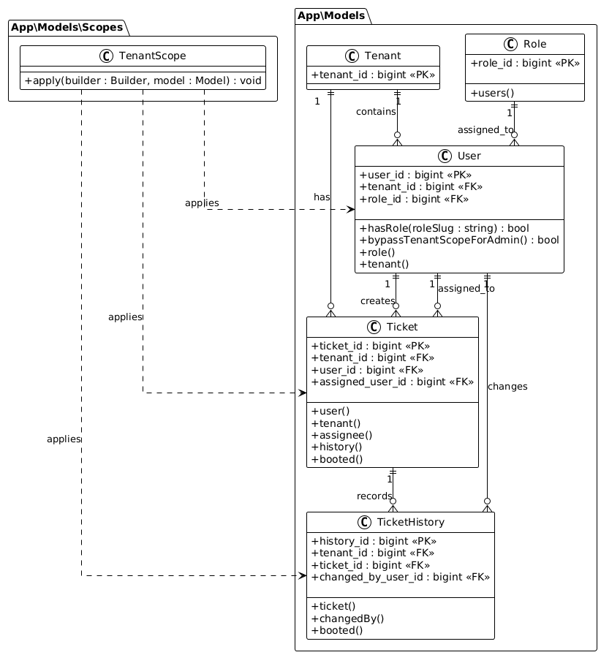
Class Diagram (Models)
I have focused on the set of domain modelsneeded for the Proof-of-Concept complaint lifecycle while enforcing multi-tenant isolation. It represents how each Model relates to each other and how TenantScope ensures user can only perform actions on ticket/users that belong to their own tenant. However, the User Model has the function ‘bypassTenantScopeForAdmin()’ which allows the system administrator to perform actions on any user regardless of tenant.

- Behavioural diagram
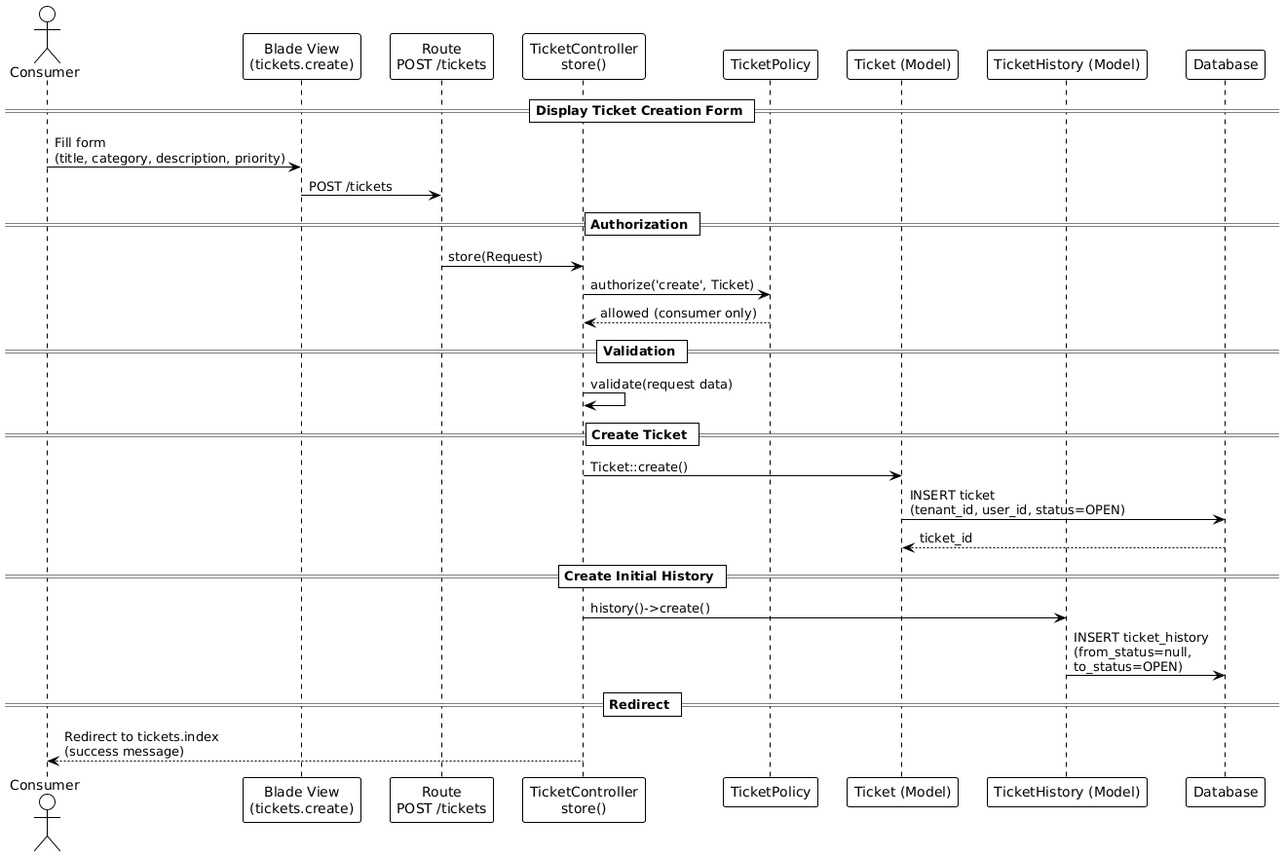
Ticket Creation Behavioural Diagram.
This shows the end-to-end flow for online complaint registration (RF01) in the Proof-of-Concept scope. I have chosen this as it highlights where the Laravel MVC layers enforce key controls (data isolation, security) – such as routing to TicketController store(), authorization in TicketPolicy( only allowed if consumer ) and request validation before writing to Ticket and TicketHistory in the database.

API endpoints
Document your APIs here if your design is service oriented. If your design is monolithic ignore this.

Data Design
Include diagrams and description of the project data design.
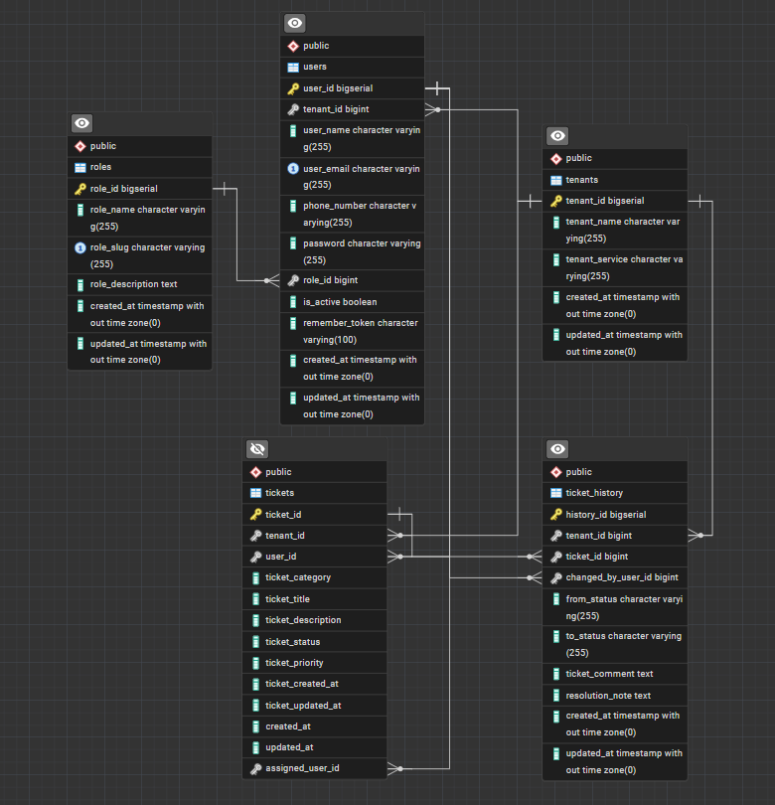

Security Considerations
Discuss security measures considered in your design; this may include authentication (SSO, multi factor authentication etc.), authorisation (role-based access) , encryption ( data level) etc.
Multi-Tenant Data Isolation
Authentication
Authorisation
Encryption of password, hash.

Appendix 1: Transparency Declaration Statements
If you take help of generative AI, please declare it here.

Appendix 2: Refined User Stories
If you feel appropriate you may want to refine the user stories provided in the case study. You may take help of generative AI. If you take help, please acknowledge that. You can also refer to SHUDev Process template to refine user stories
Consumer User Stories
1. Title: Register a Problem Online
- Priority: Must
- Estimate: 8 points
- As a consumer, I want to register a problem online so that my problem gets resolved.
Acceptance Criteria:
- Given I am logged into the consumer portal,
- When I complete the problem registration form and submit,
- Then the system should save the problem details securely, generate a unique ticket ID, and notify me.
2. Title: Call Helpdesk to Register Problem
- Priority: Must
- Estimate: 5 points
- As a consumer, I want to call the helpdesk to register my problem so that it can be logged immediately.
Acceptance Criteria:
- Given the helpdesk agent is logged into the system,
- When they log the problem details on my behalf,
- Then the system should create a ticket linked to my account and confirm registration through a notification I can access on my account.
3. Title: Get Problem Status Online
- Priority: Must
- Estimate: 5 points
- As a consumer, I want to check the status of my reported problem online so that I can be assured about the resolution.
Acceptance Criteria:
- Given I am logged in,
- When I view my dashboard,
- Then the system displays the current status of all my reported problems.
4. Title: Call Helpdesk for Problem Status
- Priority: Must
- Estimate: 3 points
- As a consumer, I want to call the helpdesk to get the status of my reported problem.
Acceptance Criteria:
- Given the helpdesk agent is logged into the system,
- When a helpdesk agent searches for my account information,
- Then the system should display case details including status.
5. Title: Provide Satisfaction Feedback Online
- Priority: Must
- Estimate: 3 points
- As a consumer, I want to provide feedback on the resolution online so that the ticket can be confirmed as resolved.
Acceptance Criteria:
- Given the case status is set as open,
- When an appropriate agent amends the details of the case,
- Then the system should set the status as closed.

Help Desk User Stories
7. Title: Receive Calls to Log Problems
- Priority: Must
- Estimate: 8 points
- As a help desk agent, I want to receive calls from consumers so that I can log their problems.
Acceptance Criteria:
- Given I am logged into the system as a help desk agent,
- When I log the problem details into the system,
- Then the problem should be stored and linked to the consumer’s account with a notification.
8. Title: Suggest Solutions to Consumers
- Priority: Should
- Estimate: 5 points
- As a help desk agent, I want to suggest solutions based on known issues so that problems can be resolved efficiently.
Acceptance Criteria:
- Given I am logged into the system,
- When I enter search keywords/phrases,
- Then relevant solutions are displayed which can be communicated to the consumer.
9. Title: Assign Support Engineer
- Priority: Must
- Estimate: 5 points
- As a help desk agent, I want to assign a support engineer to a problem if needed, so that the issue can be resolved professionally.
Acceptance Criteria:
- Given I am logged into the system as a help desk agent,
- When I am creating / amending a ticket,
- Then the system should allow me to assign the ticket to a support engineer’s account.
10. Title: Update Support Status for Consumer
- Priority: Must
- Estimate: 3 points
- As a help desk agent, I want to update the status of a problem so that the consumer is informed about ongoing resolution efforts.
Acceptance Criteria:
- Given the ticket information is displayed,
- When I add / amend ticket information,
- Then the system updates the ticket and notifies the consumer.
11. Title: Collect Feedback on Resolution
- Priority: Must
- Estimate: 3 points
- As a help desk agent, I want to collect feedback from the consumer on the resolution, so that I can confirm whether the problem is resolved satisfactorily.
Acceptance Criteria:
- Given the ticket information is displayed,
- When I change the ticket status to closed,
- Then the system updates the ticket and notifies the consumer.

Support Engineer User Stories
12. Title: Update Resolution Notes
- Priority: Must
- Estimate: 5 points
- As a support engineer, I want to update resolution notes on a ticket, so that support agents can stay informed.
Acceptance Criteria:
- Given the ticket information is displayed,
- When I add or modify resolution notes,
- Then the system updates the ticket and timestamped.

Help Desk Manager User Stories
13. Title: Monitor Resolution Time
- Priority: Must
- Estimate: 8 points
- As a Help Desk Manager, I want to monitor the resolution times for problems, so that I can identify bottlenecks and improve processes.
Acceptance Criteria:
- Given I am logged into the system as a help desk manager,
- When I view ticket reports,
- Then the system displays metrics such as average resolution time and overdue tickets.
14. Title: Monitor Support Performance
- Priority: Should
- Estimate: 8 points
- As a Help Desk Manager, I want to monitor the performance of support persons, so that I can optimize staffing and support quality.
Acceptance Criteria:
- Given I am logged into the system as a help desk manager,
- When I view support performance dashboards,
- Then the system displays individual and team support metrics.

System Administrator User Stories
15. Title: Onboard New Organization
- Priority: Must
- Estimate: 13 points
- As a system administrator, I want to onboard a new organization, so that they can utilize the CMS help desk platform.
Acceptance Criteria:
- Given I am logged into the system as a system administrator,
- When I create a new tenant,
- Then the system provides a dedicated environment with default roles for me to input organization details.
16. Title: Manage Users Within System
- Priority: Must
- Estimate: 8 points
- As a system administrator, I want to update current users within the system and register new users of any role.
Acceptance Criteria:
- Given a user account,
- When I assign or update user accounts with a role.
- Then the system applies the new privileges immediately.

Appendix 3: Use Cases
Identify use cases from the information provided in the case study. You may take help of generative AI. If you take help, please acknowledge that.
Use Cases
Register a Problem Online
Description:
A consumer submits a problem online for resolution.
Main Flow:
- Consumer logs in to the portal.
- Consumer fills out and submits the problem registration form.
- System checks if all required fields are completed.
- System saves the problem, generates a unique ticket ID.
- System links the ticket to the consumer’s profile.
- System notifies the consumer that the problem is registered.
Alternate Flow:
If required fields are missing, system prompts the user to complete them before submission.

Call Helpdesk to Register Problem
Description:
A consumer calls the helpdesk; the agent logs the problem.
Main Flow:
- Helpdesk agent logs in to the system.
- Agent collects problem details via call.
- Agent enters details in the system on behalf of the consumer.
- System generates a ticket and links it to the consumer’s account.
- System notifies the consumer through their preferred channel.
Alternate Flow:
If agent is unable to verify user identity, agent advises next steps and does not submit the ticket.

Get Problem Status Online
Description:
A consumer views the status of all reported problems.
Main Flow:
- Consumer logs in to the portal.
- Consumer navigates to their dashboard or problem history.
- System displays a list and current status for each problem ticket (open, in-progress, resolved).
Alternate Flow:
If consumer has no tickets, system shows an empty state or guidance to submit a problem.

Call Helpdesk for Problem Status
Description:
A consumer requests problem status from the helpdesk.
Main Flow:
- Helpdesk agent logs in.
- Agent searches for the consumer’s account.
- System displays all relevant cases and their current statuses.
- Agent communicates status to the consumer.
Alternate Flow:
If no cases are found, agent informs consumer and suggests confirming the account or submitting a new ticket.

Provide Satisfaction Feedback Online
Description:
Consumer gives feedback after problem resolution.
Main Flow:
- Consumer logs in and sees recently resolved problems.
- Consumer completes a satisfaction survey or rating.
- System logs feedback and marks the ticket as closed.
Alternate Flow:
If consumer does not provide feedback, system may send reminders or auto-close the ticket after a waiting period.

Receive Calls to Log Problems (Helpdesk Agent)
Description:
Helpdesk agent logs problems reported by consumers calling in.
Main Flow:
- Agent logs into the system.
- Agent records problem during the call.
- System stores the problem with a timestamp, links it to the consumer’s account, and notifies them.

Suggest Solutions to Consumers (Helpdesk Agent)
Description:
Agent uses the system’s knowledge base to find and communicate solutions.
Main Flow:
- Agent searches the solution database by keywords.
- System displays possible solutions.
- Agent communicates solution to consumer and documents outcome.

Assign Support Engineer (Helpdesk Agent)
Description:
Agent assigns a ticket to a support engineer for resolution.
Main Flow:
- Agent selects a ticket from the queue.
- System allows the agent to choose and assign a support engineer.
- System notifies the assigned engineer.

Update Support Status for Consumer (Helpdesk Agent)
Description:
Agent updates a ticket’s status as progress occurs.
Main Flow:
- Agent views details of an active ticket.
- Agent updates the ticket with new status or comments.
- System notifies the consumer of status changes.

Collect Feedback on Resolution (Helpdesk Agent)
Description:
Agent confirms with consumer if resolution is satisfactory.
Main Flow:
- Agent marks the issue as resolved.
- System triggers feedback request from the consumer.
- If feedback is positive, system closes the ticket; else, reopens or escalates as necessary.

Update Resolution Notes (Support Engineer)
Description:
Support engineer documents steps taken to resolve an issue.
Main Flow:
- Engineer logs into their portal.
- Engineer edits the ticket’s resolution notes.
- System updates the notes and timestamps the changes.

Monitor Resolution Time (Manager)
Description:
Manager tracks how long problems take to be resolved.
Main Flow:
- Manager logs into reporting dashboard.
- System displays average resolution time and overdue ticket metrics.

Monitor Support Performance (Manager)
Description:
Manager reviews team/individual performance.
Main Flow:
- Manager accesses performance dashboard.
- System displays support activity and qualitative metrics.

Onboard New Organization (System Admin)
Description:
System admin registers new organization on the system.
Main Flow:
- Admin logs in as a system admin.
- Admin creates an organization with required details.
- System provisions a tenant environment and default user roles.

Manage User Roles and Privileges (System Admin)
Description:
System admin assigns or updates user access.
Main Flow:
- Admin views list of system users.
- Admin assigns roles or modifies permissions.
- System applies changes immediately, recording the action in the audit log.

Appendix 4: Architecture Decision Records
Decision of the suitable Architectural Style
Context and Problem Statement
Designing a multi-tenant Complaint Management System (CMS) for ABC limited that allows Banking and Telecom companies to report, document and resolve complaints received by their respective customers. ABC requires a system that streamlines complaint management and resolution through different access points such as web, mobile and telephone services. Users of the bank or telecom company will log a problem then get/log the resolution of the problem utilising the system to manage the lifecycle. The system must be available 24/7 (excluding telephone) and be designed in such a way that a chatbot can be incorporated in the future to solve problems for the helpdesk agents. The system must ensure reliability, scalability (projected 20 million customers as projected by Barclays Investor Update 2024), ease of use, accessibility following the WCAG Level 2 and security following the GDPR.
Considered Architectural Styles
- Three-Tier
- Layered Monolith
- General web application
Decision Outcome
Layered Monolith
Consequences
- Good, because this style offers a high degree of scalability as each layer (business, presentation and data access) are separated from each other into physical or virtual tiers. This typically means that each layer can be developed, tested and maintained independently and if one-layer experiences high traffic or volume resources can be allocated only to where they are required. Furthermore, with the separation of presentation and database layers this means they can only communicate through the application layer, preventing users from directly accessing the database.
- Bad, if the system is not designed efficiently the layers may become too dependent on each other which reduces the scalability as it would be more difficult to scale any specific part as it will affect other layers. Furthermore, the increased complexity could work against the system and prove to be more difficult to maintain, develop and test as a process will involve multiple layers to work.

Add Link to GitHub repository that includes all project ADRs.
https://github.com/kwd0020/CMR_ADR_c3031562

Appendix 5: Incorporation of Formative Feedback
Write here about evaluation of Formative Feedback and Actions Taken in Response to Feedback.
Table 2 - Weekly Feedback
Week # | Feedback | Response
1
2
3
4
5
6
7
8 | Asked Martin for evaluation on my tech-stack ADR. | Discussed how due to the nature of Laravel I did not require to use JSON requests as this would mean setting up a server that would be redundant. Also advised to use herd development environment for Laravel.
9
10
11
12

Appendix 6:
Use if needed. You can include github link , information needed to augment your architecture or design or anything else you may feel relevant.

References

